https://docs.godotengine.org/ru/stable/tutorials/viewports/multiple_resolutions.html
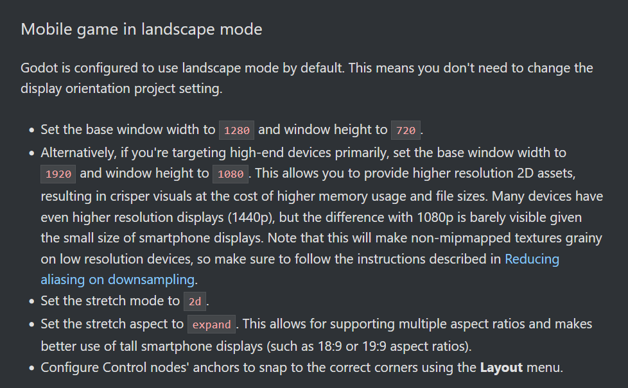
https://www.youtube.com/watch?v=gkY6X-bziHQ

